CLASSIFIED
Copy _____ of _____
1st Battalion, 7th Cavalry Regiment
1st Armored Brigade Combat Team
1st Cavalry Division
041820CFEB18
WARNING ORDER (WARNO):
JUNIPER SPEAR
HBCT TO BATTALION OPERATIONS PLAN
REFERENCES:
- Area of Operation Overlay
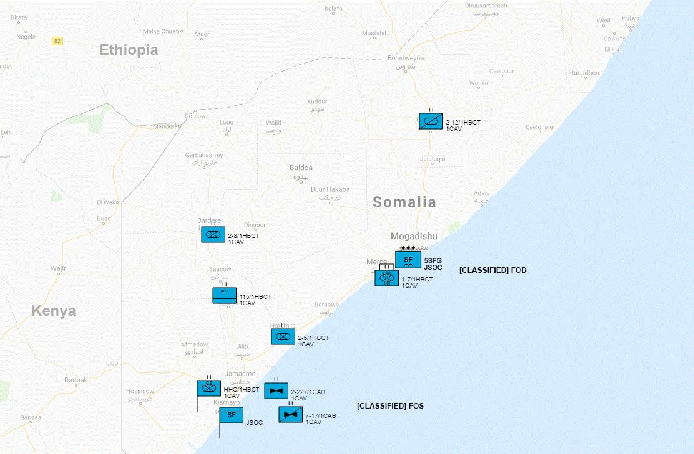
- Area of Interest Overlay
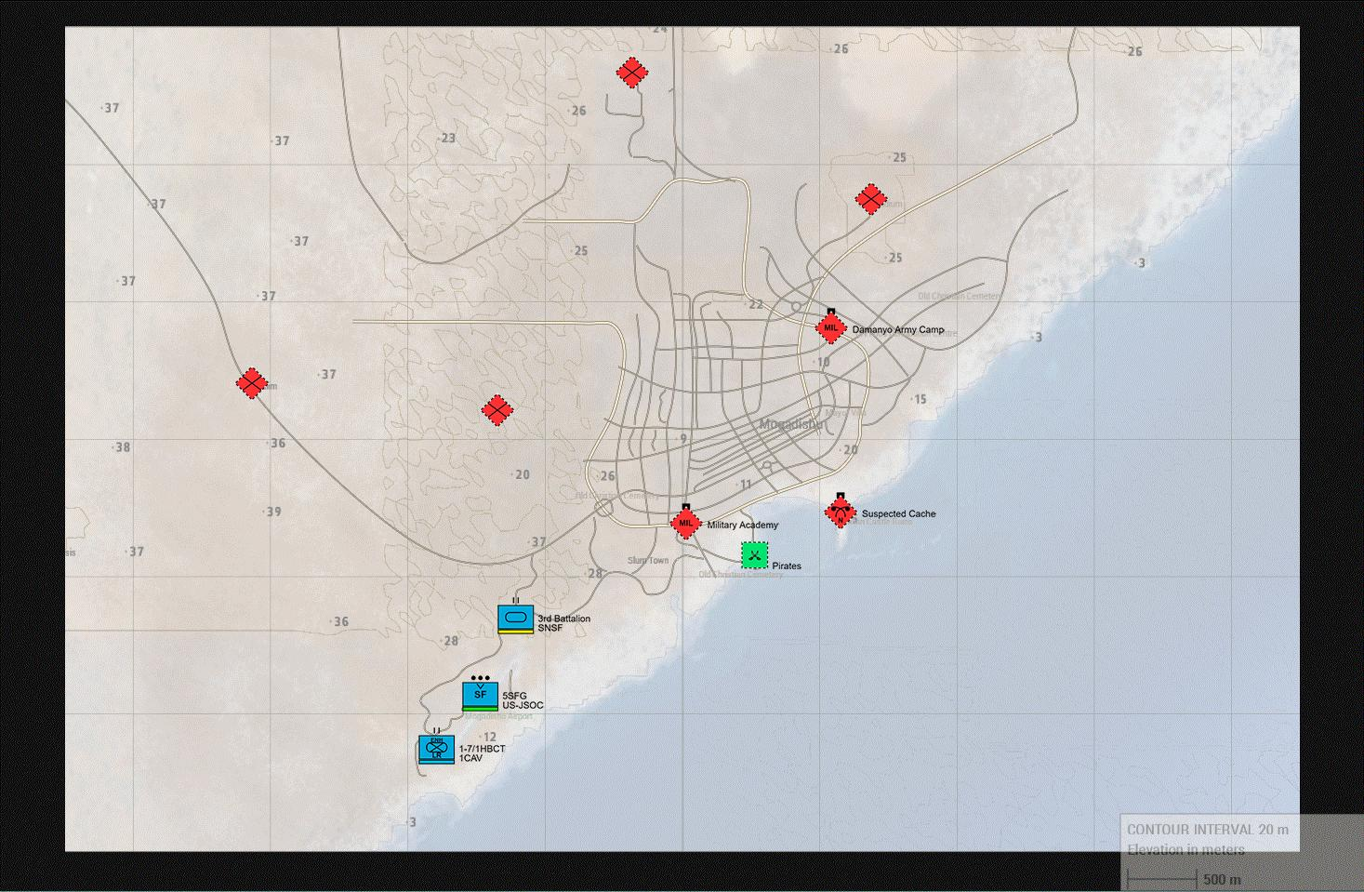
- SITUATION.
Ahmad Umar (Umar), leader of Al-Shabaab in Somalia is believed to be garrisoned in Mogadishu, along with the militants who’ve converged and taken over the city at his beckoning. With the fall of Mogadishu, militants were able to seize and now control the Military Academy and Damanyo Army Camp, along with roughly a battalion’s worth of heavy assets (see OPFOR summary for details). The militants who have taken the city have pushed all the way to the south and are threatening the SNSF / US-JSOC (5th SFG) FOB (Jazeerah) at Mogadishu Airport.
  - General.
Beginning in 2008, as an extension of the Global War on Terrorism (GWT), to combat militant Islamism and piracy in the Horn of Africa (HOA), and a component of Operation Enduring Freedom (OEF), the United States military launched Operation Enduring Freedom - Horn of Africa (OEF-HOA). Generally the US contribution to the operation, aside from advisers, supplies and other forms of non-combat support, consisted mainly of drone strikes targeted at Al-Shabaab.
Since its inception, OEF-HOA has experienced a number of notable conflicts, including the War in Somalia from 2009-present. In October 2002, the Combined Joint Task Force - Horn of Africa (CJTF-HOA) was established in Djibouti at Camp Lemonnier. Unlike other operations contained in OEF, OEF-HOA does not have a specific organization as a target. OEF-HOA instead focuses its efforts to disrupt and detect militant activities in the region and to work with willing governments to prevent the re-emergence of militant cells and activities.
    - Assessment of the Conflict.
Although the threat of Ahmad Umar detonating the devices seemed likely at first, given his early success in assembling and garrisoning a large number of insurgents in Somalia, it is believed he will no longer be able to follow through on his threat. In response, the CJTF-HOA has requested the assistance of a Heavy Brigade Combat Team (HBCT) with re-taking Mogadishu, along with neutralizing Ahmad Umar and the two nuclear warheads.
    - Policy Goals
      - US/Multinational Policy Objectives
In accordance with the US National Strategy for combating terrorism, a key objective is to deny WMDs to terrorists who seek to use them. Weapons of mass destruction in the hands of terrorists is one of the gravest threats we face. Accordingly a comprehensive approach for addressing WMD terrorism is based on a number of objectives including responding to a WMD-related terrorist attack. Once the possibility of a WMD attack against the United States or its allies has been detected, the US will:
        - seek to contain, interdict, and eliminate the threat;
        - will continue to develop requisite capabilities to eliminate the possibility of a WMD operation and to prevent a possible follow-on attack;
        - will prepare for possible WMD incidents by developing capabilities to manage the range of consequences that may result from such an attack against the United States or our interests around the world;
Should a WMD terrorist attack occur, the rapid identification of the source and perpetrator of an attack will enable response efforts and be critical in disrupting follow-on attacks. The US will develop the capability to assign responsibility for the intended or actual use of WMD via accurate attribution – the rapid fusion of technical forensic data with intelligence and law enforcement information.
      - End State.
The desired end-state of this operation is to:
        - eliminate the threat of Ahmad Umar, or any other affiliated terrorists, from utilizing the captured nuclear warheads as a WMD; and
        - Assist in stabilizing Mogadishu and returning it to SNSF control.
    - Non-US National Strategic Decisions.
In cooperation with CJTF-HOA and SNSF, all inflows of foreign terrorist fighters must be disrupted, and all terrorist encampments destroyed.
    - Operational Limitations.
Given the quick response and secretive nature of US military involvement in Somalia, only a Brigade Combat Team may be deployed, along with a select accompaniment of divisional assets to execute the operation.
  - Area of Concern
    - OA
The Operational Area (OA) is Somalia.
The United States established diplomatic relations with Somalia in 1960, following its constituent parts' independence from British and Italian administration, respectively. A 1969 coup replaced Somalia's elected government with military rule that reflected both ideological and economic dependence on the Soviet Union. Following war with Ethiopia in the 1970s, Somalia began turning toward the West, including the United States, for international support, military equipment, and economic aid. Civil war in the 1980s led to the collapse of Somalia's central government in 1991. Following this, various groupings of Somali factions, sometimes supported by outside forces, sought to control the national territory (or portions thereof) and fought one another.
From 1992-94, the United States took part in operations that aimed to provide assistance to Somalis. Numerous efforts at mediation and reconciliation were attempted over the years, and a transitional government was established in 2004. In 2012, Somalia completed its political transition with the election of a new federal parliament and speaker, the national constituent assembly's adoption of a provisional constitution, the election of a new president, President Hassan Sheikh Mohamud, and the naming of a new prime minister and cabinet. The United States formally recognized the new government on January 17, 2013.
U.S. foreign policy objectives in Somalia are to promote political and economic stability, prevent the use of Somalia as a haven for international terrorism, and alleviate the humanitarian crisis caused by years of conflict, drought, flooding, and poor governance. The United States is committed to helping Somalia's government strengthen democratic institutions, improve stability and security, and deliver results for the Somali people.
The United States also has welcomed the African Union Mission in Somalia's (AMISOM) success in driving the al-Shabaab terrorist organization out of strategically important population centers, and has underscored the continued U.S. commitment to support AMISOM and the Somali national forces in their responsibility of extending security throughout Somalia. Although the United States never formally severed diplomatic relations with Somalia, the U.S. Embassy in Somalia was closed in 1991. The United States has maintained regular dialogue with Somali authorities and other key stakeholders in Somalia through the U.S. Embassy in Kenya, which also handles consular coverage for Somalia, including to U.S. citizens in the self-declared "Republic of Somaliland."
    - Area of Interest
The area of interest for Operation Juniper Spear is Mogadishu amd areas surrounding it to the west and north.
Mogadishu is situated on the Indian Ocean coast of the Horn of Africa in southeastern Somalia. Features of the city include the Hamarwein old town, the Bakaara Market, and Gezira Beach. The Shebelle River (Webiga Shabelle) rises in central Ethiopia and comes within 30 kilometers (19 mi) of the Indian Ocean near Mogadishu before turning southwestward. Usually dry during February and March, the river provides water essential for the cultivation of sugarcane, cotton, and bananas.
The primary area of concern is the Port of Mogadishu, where Ahmad Umar and the nuclear devices are believed to be stored. Although estimates indicate it is likely the WMDs have been moved to a more secret and secure location.
The secondary area of concern is FOB Jazeera, which is being threatened by insurgent forces garrisoned in Mogadishu, and moving into the area from the east.
The tertiary area of concern are the regions of Somalia to the west and north of Mogadishu, where insurgent fighters have been moving through, and establishing camps in the process. This includes the border with Kenya, where terrorist cells have been assembling forces before moving into Somalia.
  - Deterrent Options.
No deterrent options are available at this time.
  - Risk
The primary risk to the CJTF-HOA, and population of the Horn of Africa generally, is the detonation of the two nuclear warheads by Ahmad Umar, or an affiliate.
The secondary risk to all stakeholders is the prolonged capture of Mogadishu, continued flow of insurgent into Somalia, and total destabilization of the region.
  - Enemy Forces
The primary enemy force within the Area of Interest is Al Shabaad. See Annex B [Intelligence] for details.
Harakat al-Shabaab al-Mujahideen, more commonly known as al-Shabaab, is a jihadist fundamentalist group based in East Africa. In 2012, it pledged allegiance to Al-Qaeda. Al-Shabaab's troop strength was estimated at 7,000 to 9,000 militants in 2014. As of 2015, the group had retreated from the major cities, controlling a few rural areas.
The group describes itself as waging jihad against "enemies of Islam", and is engaged in combat against the Federal Government of Somalia and the African Union Mission to Somalia (AMISOM). Al-Shabaab has been designated as a terrorist organization by Australia, Canada, the United Arab Emirates, the United Kingdom and the United States.
In early August 2011, the Transitional Federal Government troops and their AMISOM allies managed to capture all of Mogadishu from the Al-Shabaab militants. The group has also been suspected of having links with Al-Qaeda in Islamic Maghreb and Boko Haram. It attracted some members from western countries, including Samantha Lewthwaite and Abu Mansoor Al-Amriki.
In August 2014, the Somali government-led Operation Indian Ocean was launched to clean up the remaining insurgent-held pockets in the countryside. On 1 September 2014, a U.S. drone strike carried out as part of the broader mission killed Al-Shabaab leader Ahmed Abdi Godane also known as Mukhtar Abu Zubair. U.S. authorities hailed the raid as a major symbolic and operational loss for al-Shabaab. The group remains nonetheless strong and active, and has been responsible for exceptionally deadly terrorist attacks such as the Westgate shopping mall attack and the 14 October Mogadishu bombings.
The named leader of the group is Ahmad Umar.
    - Enemy Center of Gravity (COGs)
      - Strategic
Al Shabaab’s strategic COG is the southern and western regions of Somalia, as well as eastern Kenya.
      - Operational
The Enemy's operational COG is Mogadishu, which has attracted hundreds of insurgents to it within the last few weeks.
    - Enemy Critical Factors
      - Strategic
Many insurgent fighters have been told of Ahmad Umar’s actions, and have begun flooding into Mogadishu. While many fighters have made it to the city, and taken key areas, most are operating as semi-autonomous cells, with responsibility for controlling separate parts of the city. Enemy command and control (C2) may not be fully established, leaving the enemy fragmented.
      - Operational
Mogadishu has been totally taken over by insurgents, and several compounds containing SNA (3rd Brigade and Headquarters) heavy (armored and mechanized) assets have been seized. Enemy forces have spent the past weeks fortifying the city, along with capturing and executing anyone deemed a threat.
    - Enemy COAs
      - General
The current general COA seems to be to hold the city, and turn it into a “capital” for a renewed Al Shabaab insurgency. The enemy intends to use the captured nuclear weapons as a deterrent to Somali and allied forces attempting to take the city back. However it seems unlikely Ahmad Umar would detonate the WMDs in the city and kill the fighters he’s assembling.
      - Enemy’s End State
The proposed end-state by Ahmad Umar is for the Somali government to collapse, and a new civil war to engulf the region.
      - Enemy’s Strategic Objectives
Intelligence estimates indicate the enemy’s strategic objective is to control Mogadishu, topple the Somali government, and initiate a new civil war in the region.
      - Enemy’s Operational Objectives
The enemy’s current operational objectives are are secure Mogadishu from counter-attack, secure supply lines leading in and out of the city, and to hide and protect the WMDs.
      - Enemy CONOPs
The first components of the enemy’s Concept of Operation has been executed with the capture of Mogadishu. Intelligence estimates indicate the enemy intends on occupying Mogadishu indefinitely, while using it and the captured WMDs as a rallying center for amassing a large force, and destroying the government of Somalia.
    - Enemy Logistics and Sustainment
Forces that have amassed within Mogadishu are being sustained through supplies and equipment captured within the city and surrounding areas. In addition, it is believed Somali pirates have been selling stolen supplies to insurgents through the Port. Additionally, intermittent supply lines and convoys including additional fighters, food, and equipment have been flowing into the OA from the west and south (Kenya).
    - Other Enemy Forces / Capabilities
Insurgents occupying Mogadishu have captured and are using SNSF equipment, including SNA 3rd Battalion heavy assets. Insurgents flowing into the OA are generally motorized and lightly armed, although many are augmented by CSW.
    - Enemy Reserve Mobilization
Unknown / Not applicable.
  - Friendly Forces
    - The primary objective of 1ABCT-1CAV is to find and neutralize the two nuclear warheads believed to be in the possession of Umar. The secondary objective of 1ABCT-1CAV is to find and neutralize Umar. The tertiary objective of 1ABCT-1CAV is to push out the militants occupying Mogadishu and assist in restoring stability to the region.
    - Friendly COGs
      - Strategic
        - Camp Lemonnier, Djibouti (CJTF-HOA).
        - Headquarters and Headquarters Company (HHC) will be based at FOS [Classified] Kismayo, along with US-JSOC.
      - Operational
        - 1-7 CAV (CAB) [Enhanced Task Force] will be based at FOB Jazeerah, Mogadishu Airport, along with 5th SFG.
        - 2-5 CAV (CAB) will establish a reinforcing position and be based at an FOB [TBD], Haramka, along with 115th BSB and SNSF.
        - 2-8 CAV (CAB) will establish a blocking position and be based at an FOB [TBD], Bardere, along with SNSF.
        - 2-12 CAV (ARS) will establish a blocking position and be based at an FOB [TBD], Bulobarde, along with SNSF.
        - 115 BSB will establish a logistics hub and be based at an FOB [TBD], Haramka, along with 2-5 CAV and SNSF.
        - 2-227 AVN (General Support) will establish an aviation command center and be based at FOS [Classified], Kismayo, along with HHC,7-17th CAV, and US-JSOC.
        - 7-17 CAV (Attack Reconnaissance) will establish an aviation command center and be based at FOS [Classified], Kismayo, along with HHC, 2-227th AVN, and US-JSOC.
    - Friendly Critical Factors
      - Strategic
        - Surround Umar and keep him and the WMDs from escaping.
        - Block additional flow of fighters into Mogadishu.
      - Operational
        - 5SFG detachment at FOB Jazeerah is at full strength, however has taken some damage from previous encounters.
        - Find and neutralize WMDs quickly, and avoid prolonged conflict as it will lead to increased likelihood of WMD usage.
        - Avoid civilian casualties.
    - Multi-National Framework
      - Established and coordinated through CJTF-HOA at the strategic level.
      - Established and coordinated through US-JSOC at the operational level.
      - Kenyan and Ethiopian forces are FRIENDLY and coordinating with CJTF-HOA, etl. To secure their respective borders.
    - Supporting Command and Agencies
      - 3rd Battalion SNSF is fortified in a blocking position on the northside of FOB Jazeerah. They have taken heavy losses and are damaged. They are also down a battalion worth of heavy (combined arms) assets, which were captured from Damanyo Army Camp.
      - Non-essential / non-combat SNSF and Somali Federal Government personnel are being evacuated to FOB Kismayo. All encountered personnel leaving the AI should be directed to the logistics hub setup at Haramka.
  - Assumptions
    - Threat Warning / Timeline.
OPFOR pose an immediate threat. They are entrenched in Mogadishu, as well as surrounding it to the west and north. OPFOR will likely initiate contact via ambush, and fight using overwhelming numbers, along with MOUT to their advantage.
    - Pre-Positioning / Regional Access.
SNSF has already been pre-positioned at FOB sites, per Brigade Campaign Plan. Brigade elements will link-up with SNSF at pre-determined locations within their assigned regions. SNSF, along with US-JSOC is providing limited security throughout the region, although 1ABCT-1CAV is responsible primarily for its own security.
    - In-Place Forces.
3rd Battalion SNSF is fortified in a blocking position on the northside of FOB Jazeerah. SNSF Brigade Headquarters and 5th SFG is garrisoned at FOB Jazeerah.
OPFOR is pre-positioned throughout the Mogadishu and surrounding areas. See Annex B - Intelligence for details.
    - Strategic Assumptions.
OPFOR will likely hold position, and utilize guerrilla style tactics in defense of Mogadishu. OPFOR will likely be reinforced from the west (Kenya). Umar is unlikely to detonate WMDs, although preparation for an event, along with CBRN capabilities to handle the WMDs when captured will be required.
  - Legal Considerations
    - ROE.
Strict ROE applies for contact with all civilians. Most civilians in Mogadishu should be unarmed. Civilians outside of Mogadishu may be armed. Engage only in self-defense, unless mission parameters dictate otherwise.
    - International Law (inc. Law of War).
While BLUFOR is to operate under all applicable International Treaties, along with principles and substantive examples of the Laws of War; OPFOR is not bound by, will have any intent on abiding to the same principles; including the lawful conduct of belligerent actors, persons parachuting from an aircraft in distress, or recognition of Red Cross, Red Crescent, Magen David Adom, and white flags. OPFOR may attempt to use civilians as human shields, and may take and torture hostages.
    - US law.
Criminal law is usually territorial. It is a matter of the law of the place where it occurs. Nevertheless, a number of American criminal laws apply extraterritorially outside of the United States. As a professional standing Army, representing its host nation, the all personnel within the United State Armed Forces are subject to extraterritorial application of United States Law. Crimes subject to prosecution when committed overseas includes homicide, kidnapping, assault, property destruction, threats, theft, and counterfeiting.
    - HN and partner nation policies.
Somali Federal government has authorized the presence of CJTF-HOA and expanded this recognition for the purposes of re-taking their national capital of Mogadishu. CJTF-HOA forces are considered allied to the Somalia Federal government and people.
    - Status of forces agreements.
Per USAFRICOM status of forces agreements (SOFAs) do not exist in the Area of Operation. Therefore, U.S. military personnel have the same status as tourists—they are subject to visa requirements, customs restrictions, taxes, and all the laws of the host state. Note that states have no independent obligation to provide visitors with even basic due process rights. Essentially, absent specific legal authority, one enters and operates in a foreign setting at their own peril. For the purposes of Operation Juniper Spear, the Somali Federal Government has provided the United States a grant of immunity. This grant of immunity will likely only last the duration of the operation, and is not to be prolonged any further then necessary.
    - Other bilateral treaties and agreements.
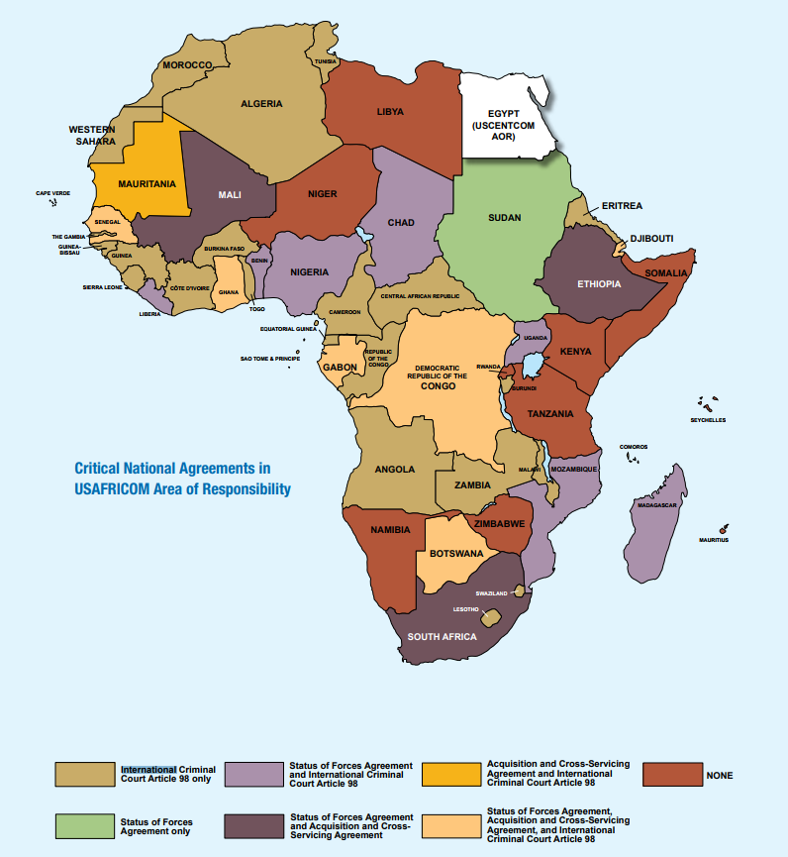
    - HN agreements to include HNS agreement.
There are no critical national agreements in place with the Somali Federal government at this time.
- MISSION
In conjunction with Operations Campaign Plan - Operation Juniper Spear (201820CJAN18), 1st Battalion, 7th Cavalry Division has been assigned as the 1st Armored Brigade Combat Teams’ Enhanced (Long-Range) Maneuver Element. It is the “tip of the spear” for the Brigade, with primary responsibility for finding and neutralizing the WMDs and Umar.
After 1st Armored Brigade Combat Team, 1st Cavalry Division has deployed to FOS Kismayo, and then set up its respective battalions in and around Mogadishu, it will be up to 1-7CAV to conduct the primary combat functions for the operation. 1-7CAV is to move from FOS [Classified], Kismayo north to FOB Jazeerah at Mogadishu Airport. Once there, it is to link up with 5th SFG and SNSF element there to fortify and defend the FOB. Once the FOB is secure, it will find and neutralize the WMDs and Umar. Once the primary objective is achieved, 1-7CAV is to clear out all OPFOR militants, and assist in re-establishing stability, in and around the City.
- EXECUTION
  - Initial Commander's Intent.
While the rest of the Brigade will surround and cut-off OPFOR movement around Mogadishu, 1-7 CAV will swiftly and decisively secure FOB Jazeerah, then find the WMDs and Umar, and neutralize them both.
  - Concept of Operations.
    - Phases.
      - Deployment. 1-7 CAV will deploy to FOB Jazeerah and secure it from further threat.
      - Reconnaissance. 1-7 CAV will conduct reconnaissance and intelligence gathering missions to ascertain the location and disposition of the WMDs and Umar.
      - Initial Conduct. 1-7 CAV will move into the city and secure key routes and strong points.
      - Follow-on / Support. 1-7 CAV will provide medical and humanitarian assistance to BLUFOR and civilians as needed.
      - Breakthrough. 1-7 CAV will secure the Military Academy and Damanyo Army Camp.
      - Exploitation. 1-7 CAV will neutralize the WMDs and Umar.
      - Stability. 1-7 CAV will assist SNSF with pushing out all OPFOR militants and restore stability to Mogadishu.
    - Primary Maneuver Elements. 1-7 CAV has been enhanced with additional (long-range) assets including an air assault company, and Ranger platoon. To swiftly and decisively conduct its operations, 1-7 CAV will be assembled into “maneuver elements”, also known as “task units” enabling the Commander to deploy forces modularly, as needed.
Primary | Secondary
Air Assault  Mechanized Infantry | Aviation  Ranger  Support  Medical  Headquarters
    - Fire Support. Given only 1ABCT-1CAV has been deployed on such short-notice, no DIV-ARTY is available. Only indirect fire support will be through heavy and light mortars organic to the Brigade. Direct fire support can be provided by 7-17 CAV, with emphasis on eliminating heavy targets only.
  - Tasks to Maneuver Units.
Unit | Task
Air Assault | Conduct air-based long-range, swift, and light reconnaissance and offensive missions. Provide QRF as needed.
Mechanized Infantry | Conduct ground based reconnaissance, offensive, and defensive missions.
Aviation | Conduct reconnaissance, offensive, and defensive missions. Provide CAS as needed.
Ranger | Conduct intelligence gathering, HVT extraction, and related missions. Provide QRF as needed.
Support | Establish strong-points and obstacles, breach obstacles, and enhance ground based maneuver.
Medical | Provide medical and humanitarian support.
Headquarters | Conduct leaders’ reconnaissance and mission planning.
  - Tasks to Combat Support Units.
  - Coordinating Instructions.
    - HHC to establish Battalion Command Post at FOB Jazeerah, Mogadishu Airport.
    - All other coordinating tasks to be determined at the Task Unit level, via OPORD.
- SERVICE SUPPORT
  - General.
    - Sustainment operations will be coordinated with 115th BSB, Haramka.
    - Resupply will be coordinated with US-JSOC and SNSF at FOB Jazeerah.
    - Battalion CCP (Surgical Center) will be based at FOB Jazeerah.
    - Special medical instructions - Ensure all personnel are checked for radiation exposure. Ensure proper setup for CBRN.
  - Materials and Services.
    - Supply:
      - Class I: Request food and water resupply from 115 BSB at logistics hub.
      - Class II: SOP. MOPP Ready through MOPP 4.
      - Class III: Request POL resupply from 115 BSB at logistics hub.
      - Class IV: Request construction supplies from 115 BSB at logistics hub.
      - Class V: Request ammo resupply from 115 BSB at logistics hub.
      - Class VI: SOP.
      - Class VII: SOP.
      - Class VIII: Request medical support and resupply from 115 BSB at logistics hub. Medical units at all echelons to be CBRN equipped.
      - Class IX: Request repair parts from 115 BSB at logistics hub.
      - Class X: N/A.
      - Distribution Methods. Major distribution through 115 BSB at logistics hub. Distribution at echelons below battalion will be made through S4, as well as supply companies and platoons.
    - Transportation.
      - Ground transportation for logistics provided by 115 BSB.
      - Air transportation provided by 2-227 AVN.
    - Services. All services to be setup at FOB Jazeerah.
    - Maintenance.
      - Priority of Work is mechanized infantry assets, then aviation.
      - Plan of Maintenance is in field, then send all damaged equipment back to 115 BSB at logistics hub for repair.
  - Medical Evacuation.
    - Medical evacuation in field will be handled by 2-227th AVN (aeromedical evacuation) to battalion field hospital at FOB Jazeerah.
    - Medical evacuation for critical / mortally wounded will be handled by 115 BSB via ground and air transportation with support of 2-227th AVN to logistics hub, and then to FOS [Classified], Kismayo.
  - Personnel.
    - Reinserts will be brought back to FOB Jazeerah from 115 BSB logistics hub via 2-227 AVN.
    - EPWs are to be detained, searched, and cleared of all weapons and equipment, then consolidate at FOB Jazeerah for transport to FOS [Classified], Kismayo.
  - Miscellaneous. N/A.
- COMMAND AND SIGNAL
  - Command.
    - HHC 1ABCT is based out of FOB [Classified], Kismayo.
    - Battalion CP located at FOB Jazeerah, Mogadishu.
    - Succession of Command.
      - Battalion Commander
      - Battalion Executive Officer
      - Battalion Sergeant Major
      - S3 Officer in Charge
    - Adjustments to the unit SOP. None.
  - Signal
    - SOI. Handled within Task Unit OPORD.
    - Method of communication by priority. Handled within Task Unit OPORD.
    - Pyrotechnics and signals. Handled within Task Unit OPORD.
    - Codewords. Handled within Task Unit OPORD.
    - Challenge and password (behind friendly lines). Handled within Task Unit OPORD.
    - Number combination (forward of friendly lines). Handled within Task Unit OPORD.
    - Running password. Handled within Task Unit OPORD.
    - Recognition signals (near/far, day/night). Handled within Task Unit OPORD.
    - Special instructions for RTOs. Handled within Task Unit OPORD.

ACKNOWLEDGE: COL A. Grgich
Commanding
Table X. List of Attachments and responsible staff officers
Annex | Responsible Officer | Included / Omitted
ANNEX A - TASK ORGANIZATION | S-3 | Omitted. See Section 3(c) of WARNO.
ANNEX B - INTELLIGENCE | S-2 | Included
ANNEX C - OPERATIONS | S-3 | Omitted. TBD based on future missions.
ANNEX D - FIRES | Fire Support Officer | N/A
ANNEX E - PROTECTION | Chief of Protection | Omitted. Brigade echelon.
ANNEX F - SUSTAINMENT | S-4 | Omitted. Brigade echelon.
ANNEX G - ENGINEER | Engineer Officer | Omitted. TBD based on future missions.
ANNEX H - SIGNAL | S-6 | Omitted. Brigade echelon.
ANNEX I - Not Used
ANNEX J - PUBLIC AFFAIRS |  | Omitted. See Brigade Campaign Plan.
ANNEX K - CIVIL AFFAIRS OPERATIONS | S-9 | Omitted. See Brigade Campaign Plan.
ANNEX L - INFORMATION COLLECTION | S-3 | Omitted. See Section III.B.1(b) of WARNO.
ANNEX M - ASSESSMENT | S-3 | Omitted. Brigade echelon.
ANNEX N - SPACE OPERATIONS | Space Operations Officer | Omitted. Brigade echelon.
ANNEX O - Not Used
ANNEX P - HOST NATION SUPPORT | S-4 | Omitted. Brigade echelon.
ANNEX Q - KNOWLEDGE MANAGEMENT | Knowledge Management Officer | Omitted. Brigade echelon.
ANNEX R - REPORTS | S-3, S-5, and Knowledge Management Officer | Included.
ANNEX S - SPECIAL TECHNICAL OPERATIONS | Special Technical Operations Officer | Omitted. Brigade echelon.
ANNEX T - Spare
ANNEX U - INSPECTOR GENERAL | Inspector General | Omitted. Brigade echelon.
ANNEX V - INTERAGENCY COORDINATION | S-3 and S-9 | Omitted. Brigade echelon.
ANNEX W - OPERATIONAL CONTRACT SUPPORT | S-4 | Omitted. Brigade echelon.
ANNEX X - Spare
ANNEX Y - Spare
ANNEX Z - DISTRIBUTION | S-3 | Omitted. Brigade echelon.

ANNEX B - INTELLIGENCE
No. _____ of _____
1st Battalion, 7th Cavalry Regiment
1st Armored Brigade Combat Team
1st Cavalry Division
041820CFEB18
ANNEX B (INTELLIGENCE) TO
CAMPAIGN PLAN/ORDER
REFERENCES:
Overlay 1 - See WARNO.
Time Zone Used Throughout the Plan/Order: East Africa Time Zone (UTC +03:00)
Situation.
See WARNO.
Area of Interest.
See WARNO.
Area of Operations.
See WARNO.
- Terrain.
  - The terrain outside of Mogadishu is flat desert. It will provide for little cover, or concealment for both BLUFOR and OPFOR. Presume that all movements by BLUFOR outside of the city are being watched.
  - The terrain inside Mogadishu is MOUT. This is to the OPFOR’s advantage. Refer to US Forces Somalia After Action, Center of Military History. OPFOR have established blocking positions throughout the south and west sides of the city, as well as fortified the castle across from the port, along with the Military Academy and Damanyo Army Camp. OPFOR may also use IEDs, VEIDs, and suicide bombers to deter BLUFOR movement into the city.
- Weather.
  - Season: Summer
  - High Temp: 92 °F
  - Low Temp: 72 °F
  - Mean Temp: 82 °F
  - Precipitation: 0.11"
  - Humidity: 41%
  - Dew Point: 56 °F
  - Wind: 9 mph
  - Pressure: 30.00 "Hg
  - Visibility: 17 mi
- Enemy Forces (Locations / Composition / Disposition).
Locations | Grid Ref. | Composition | Disposition
Military Academy | 943-100 | Combined Arms | Unknown
Damanyo Army Camp | 957-110 | Combined Arms | Unknown
Castle (Suspected Cache) | 943-111 | Infantry | Unknown
Stadium | 967-112 | Combined Arms | Unknown
Port | 941-105 | Infantry | Unknown
Ahmad Umar | UNK | Infantry | Unknown
Al Salim | 954-068 | Motorized Infantry | Unknown
Unnamed Buildings | 950-085 | Motorized Infantry | Unknown
Unnamed Buildings | 975-057 | Motorized Infantry | Unknown

- Friendly Forces.
  - 5th SFG - Provide intelligence through direct reconnaissance, as well as UAVs from FOS [Classified], Kismayo, SNSF intelligence gathering, and HUMINT.
  - SNSF - Provide intelligence through contact with OPFOR.
- Interagency, Intergovernmental, and Nongovernmental Organizations.
None present at this time, except for scattered remnants of the AMISOM have been fleeing Mogadishu and consolidating at FOB Jazheera (Mogadishu) before moving south.
- Civil Considerations.
Civilians remain in Mogadishu. Many are sympathetic to Al Shabaab. Many are trapped.
- Attachments and Detachments. None.
- Assumptions.
  - OPFOR is heavily entrenched and fortified.
  - OPFOR will likely use IEDs, VIEDs, and suicide bombers to prevent movement into the city.
  - OPFOR may use civilians as human shields.
  - Umar and WMDs are in hiding at the suspected supply cache.
ACKNOWLEDGE: SGT K. Schmidtg
S-2 NCOIC
 | MOST WANTED  TERRORIST
Ahmad Umar
Ahmed Omar (Somali: Axmed Cumar, Arabic: أحمد عمر‎), also known as Ahmed Diriye and Abu Ubaidah, is the Emir of the Somalia-based Islamist group Al-Shabaab. He was listed by the US State Department as a Specially Designated Global Terrorist in April 2015.

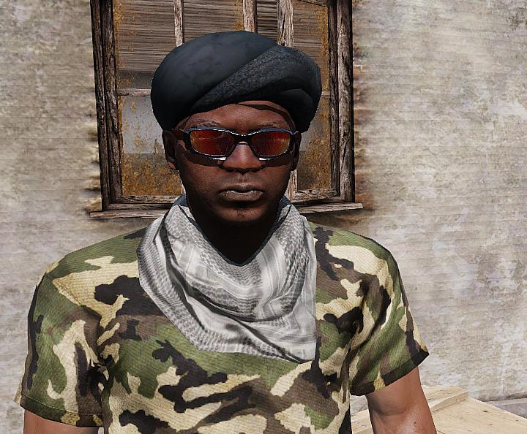

Aliases: Axmed Cumar, Ahmed Diriye, and Abu Ubaidah
Dates of Birth Used: Unknown | Place of Birth: Somalia
Hair: Black | Eyes: Brown
Height: 5’11” | Weight: 195 lbs.
Build: Thin | Complexion: Dark
Sex: Male | Citizenship: Somalia
Languages: English, Unknown | Scars and Marks: Unknown.

REWARD
The rewards For Justice Program, United States Department of State, is offering $6,000,000 for information leading directly to the apprehension or conviction of Ahmad Umar.
REMARKS
He is believed to be in his forties and is a member of the Bajimaal section of the Dir clan from the Kismayo region of Somalia.
SHOULD BE CONSIDERED ARMED AND DANGEROUS
If you have any information concerning this person, please contact your local FBI office or the nearest American Embassy or Consulate.

ANNEX R - REPORTS
No. _____ of _____
1st Battalion, 7th Cavalry Regiment
1st Armored Brigade Combat Team
1st Cavalry Division
041820CFEB18
ANNEX R (REPORTS) TO
CAMPAIGN PLAN/ORDER
REFERENCES:
Overlay 1 - See WARNO.
Time Zone Used Throughout the Plan/Order: East Africa Time Zone (UTC +03:00)
Reports.
- CBRN
  - SUMMARY REPORT OF NUCLEAR DETONATIONS [NUDETSUM]
Use to report information pertaining to nuclear detonations on areas outside the North American continent. This report will support damage assessment at the national level. Reference: FM 3-14.
  - ENVIRONMENTAL CONDITION REPORT [ECR]
Use to send periodic information (interim snapshots) of the environmental status of specific sites (assembly areas, base camps, logistical support areas, and medical facilities) where hazards are likely to occur, which can result in significant, immediate and/or long-term effects on the natural environment and/or health of friendly forces and noncombatants. Send IAW unit SOPs and commander’s direction.
  - SUPPORT-DAMAGE AVOIDANCE AREA [SPRT.DAACAT]
Use (1) to establish nuclear damage categories and (2) to disseminate command guidance establishing chemical avoidance criteria within damage avoidance areas. Reference: FM 3-3-1.
  - NBC 1/ROTA REPORT [NBC1]
Use to provide the observer’s initial report giving basic data on a nuclear attack, biological attack, chemical attack, or releases other than attack (ROTA). This NBC1/ROTA voice message accommodates all NBC1/ROTA reporting. Reference: ATP-45 and FM 3-7.
  - NBC 2/ROTA REPORT [NBC2]
Use to disseminate evaluated data of a nuclear attack, biological attack, chemical attack, or releases other than attack (ROTA). This NBC2/ROTA accommodates NBC2/ROTA (NUC, BIO, or CHEM) reporting requirements. Reference: ATP-45 (A) and FM 3-7.
  - NBC 3/ROTA REPORT [NBC3]
Use to pass immediate warning of predicted contamination and hazard areas following NBC attacks or releases other than attack (ROTA) hazards. This NBC3/ROTA voice message accommodates all NBC3/ROTA (NUC, BIO, or CHEM) reporting requirements. Reference: ATP-45 and FM 3-7.
  - NBC 4 REPORT [NBC4]
Use to report NBC monitoring and survey results. This NBC4 voice message accommodates all NBC4 (NUC, BIO, or CHEM) reporting. Reference: FM 3-7.
  - NBC 5 REPORT [NBC5]
Use to pass information on areas of actual nuclear, biological, or chemical contamination. This NBC5 voice message accommodates all NBC5 (NUC, BIO, or CHEM) reporting requirements by selected use of sets. Reference: FM 3-7.
  - NBC 6/ROTA REPORT [NBC6]
Use to pass detailed information on chemical and biological attacks and releases other than attack (ROTA) hazards. This NBC6/ROTA voice message accommodates all NBC6/ROTA (BIO or CHEM) reporting requirements. Reference: ATP-45 (A) and FM 3-7.
  - DECONTAMINATION REQUEST [DECONREQ]
Use to request decontamination by contaminated units. Initially request on CMD net, then send all traffic through administrative or logistics net. Send initial request with PRIORITY precedence. Reference: FM 3-5.
  - DECON SITE REPORT [DECONSTREP]
Use to update progress and status of decontamination sites in a unit’s area of operation. Submit as required IAW unit SOPs. Transmit on O&I ROUTINE precedence. Reference: FM 3-5.
- RECONNAISSANCE
  - ROUTE REPORT [ROUTEREP]
Use to report results of route reconnaissance. Reference: FM 5-34, FM 17-95, and FM 17-98.
  - SURVEILLANCE AND RECONNAISSANCE PLAN REPORT [SURRECONREP]
Use to report reconnaissance and surveillance plans. Reference: FM 34-2-1.
  - RECONNAISSANCE NICKNAME REPORT [RECON 1]
Use to report additions, changes, or deletions of operation order numbers and associated nicknames for reconnaissance. Reference: FM 34-2-1and FM 101-5.
  - RECONNAISSANCE TRACK REPORT [RECON 2]
Use (1) to submit proposed reconnaissance tracks for mission approval and (2) to modify or delete existing active reconnaissance tracks. Reference: FM 34-2-1 and FM 101-5.
  - RECONNAISSANCE SCHEDULING REPORT [RECON 3]
Use (1) to provide selected and specific data on proposed reconnaissance mission schedules, (2) to make changes to approved schedules, and (3) to inform of CINC/unit intention to fly specific reconnaissance missions. Reference: FM 34-2-1 and FM 101-5.
  - RECONNAISSANCE FOLLOWING REPORT [RECON 4]
Use to provide specific information pertaining to a reconnaissance mission flight. Reference: FM 34-2-1, FM 100-103, and FM 101-5.
  - RECONNAISSANCE EXPLOITATION REPORT [RECCEXREP]
Use to provide an abbreviated imagery interpretation report in a tactical situation
- MISSION
  - WAR CRIME REPORTABLE INCIDENT REPORT [WCRIR]
Use to convey flash traffic to the commander relating to a possible, suspected, or alleged violation of the law of war discovered within the command.
  - PATROL REPORT [PATROLREP]
Use to report information and combat actions obtained on mounted and dismounted patrols. Reference: FM 17-98, FM 17-95, FM 7-92, and FM 34-3.
  - EXPLOSIVE ORDNANCE DISPOSAL SUPPORT [EODSPT]
Use (1) to request explosive ordinance disposal (EOD) support, (2) to report the results of an EOD mission, or (3) to request EOD support to protect designated very important persons. Reference: FM 9-15.
  - MEDICAL SITREP [MEDSITREP]
Use to convey a quick, consolidated medical status report as a snapshot rather than a full report. Reference: FM 8-10-3.
  - SPOT REPORT [SPOTREP]
Use to send information to provide timely intelligence or status regarding events that could have an immediate and significant effect on current planning and operations. Reference: FM 17-15, FM 17-98, and FM 7-7.
  - BATTLE DAMAGE ASSESSMENT REPORT [BDAREP]
Use to provide a timely and accurate estimate of damage resulting from the application of military force, either lethal or non-lethal, against a predetermined objective. Reference: FM 9-43-1.
  - SAEDA REPORT [SAEDAREP]
Use to provide notification of a Subversion and Espionage Directed Against the Army (SAEDA) incident. Reference: FM 34-60 and AR 310-50.
  - PRELIMINARY TECHNICAL REPORT [PRETECHREP]
Use to disseminate initial technical information on captured or acquired foreign material and ordnance. Reference: FM 34-54 and FM 34-60.
  - SEARCH AND RESCUE INCIDENT REPORT [SARIR]
Use to report any situation that may require a search and rescue effort. Reference: FM 1-108 and FM 1-513.
  - SURVIVABILITY REPORT [SURREP]
Use to report the completion of survivability tasks. Survivability tasks include digging, revetment, camouflage, and hardening of buildings. Reference: FM 5-34, FM 5-100, and FM 5-102.
  - ENEMY/PRISONER OF WAR REPORT [EPOW]
Use to convey status and disposition of unit’s EPWs. Send IAW unit SOPs. Reference: FM 19-40.
  - LACE REPORT [LACE]
Used to report status after contact with the enemy.
  - CLOSE AIR SUPPORT SUMMARY [CASSUM]
Use to provide timely reports of close, air-support missions and other information obtained during post-flight aircrew debriefing. Reference: FM 6-71.
  - ACCIDENT REPORT/SERIOUS INCIDENT REPORT [SIR]
Use to convey flash traffic to the commander and command post relating to an accident or serious incident within the command. Use FLASH precedence on CMD nets. For all other stipulations and instructions refer to AR 190-40 (SIR) and AR 385-40 (Accident Report)
  - NBC SITUATION REPORT [NBCSITREP]
Use to report current NBC situation and chemical units’ activity. Send on a scheduled time line IAW unit SOPs, such as 0500, 1100, 1700, and 2300 daily. This is considered routine and is a normal report not indicated in NBC 1 through NBC 6 reports. Reference: FM 3-7.
  - DETAINED CIVILIAN PERSONNEL REPORT [DETAINCIVREP]
Use to provide commander of incidents where the unit has detained civilian personnel. Send IAW unit SOPs. Reference: FM 19-40.
  - ENEMY/FRIENDLY/UNIT MINEFIELD/OBSTACLE REPORT [MINOBREP]
Use to report all obstacles on the battlefield after developing a report. Disseminate information and report to all command posts and units in the area of operation as soon as possible. Reference: FM 90-13-1, FM 20-32, and FM 5-34.
  - AIR SUPPORT REQUEST [AIRSUPREQ]
Use to request preplanned and immediate close-air support, interdiction, reconnaissance, surveillance, escort, helicopter airlift, and other aircraft missions. For expedient hard copy or voice request use DD Form 1972 (Revised) 15 NOV 1994 (see Figure A020) or Sample TACAIR Briefing Form (see Figure A015).
- CAMPAIGN
  - CLOSURE REPORT [CLOSEREP]
Use to inform commander of status of movement and capability of the unit to conduct future operations. Submit upon completion of movement as directed by commander. Reference: FM 71-2 and FM 71-3.
  - OPERATION REPORT [OPREP]
Use to report operational situations, problems, recommended or intended courses of action, and other items not reported elsewhere. Send as determined by higher headquarters or by necessity of subordinate headquarters. Reference: FM 100-15, FM 71-100, and FM 101-5.
  - SLANT REPORT [SLANTREP]
Use to give the commander accurate and routine information regarding status of critical personnel and equipment necessary for the unit’s operation success. Submit when necessary or as directed. The commander designates the information to report during planning or by unit SOPs. Reference: FM 71-2 and FM 71-3.
  - RULES OF ENGAGEMENT AUTHORIZATION [ROEAUTH]
Use to authorize or refuse the implementation of specific rules of engagement. Reference: FM 101-5.
  - REQUEST FOR INFORMATION [RFI]
Use to request information from requesting unit’s command post or other units. Reference: FM 101-5.
  - FRAGMENTARY ORDER [FRAGO]
Use to send timely changes of existing orders to subordinate and supporting commanders while providing notification to higher and adjacent commands. Send FLASH precedence O&I or CMD IAW unit SOPs. Reference: FM 101-5.
  - CLASS IV BULK BARRIER MATERIALS REQUEST [BLKIVREQ]
Use to report a periodic update, forecast, or formal request of Class IV barrier materials a unit requires. Reference: FM 5-102, FM 20-32, and FM 90-7.
  - PERSONNEL STATUS REPORT [PERSTAT]
Use to report the status of the unit’s personnel. Reference: FM 12-6.
  - TRANSPORTATION SUPPORT REQUEST [TRANSSPTREQ]
Use to request transportation support other than airlift support. Reference: FM 701-58.
  - MAINTENANCE SUPPORT REQUEST [MAINTSPTREQ]
Use to request maintenance support. Reference: FM 9-43-1.
  - AVIATION (ARMY ROTARY WING) MISSION/SUPPORT REQUEST [AVIAREQ]
Use to request Army aviation units for support. Send from subordinate units to division/corps aviation cell at the main command post. Reference: FM 1-100 and FM 1-114.
  - OPERATION ORDER [ORDER]
Use to transmit the standard five-paragraph operation order (OPORD) and operation plan (OPLAN) that provide plans, instructions, and directives to subordinate and supporting military organizations. Reference: FM 101-5, FM 71-100, and FM 100-15.
  - UNIT SITUATION REPORT [UNITSITREP]
Use to inform commanders of operational plans, unit readiness, and operational situations or summaries. Reference: FM 100-15, FM 71-100, FM 71-3, and FM 71-2.
  - OPERATIONS PLAN CHANGE [PLANORDCHG]
Use to update or change existing operations plans. (Note: Use FRAGO to change OPORD.) Reference: FM 100-15, FM 71-100, and FM 101-5.
  - SEARCH AND RESCUE (SAR) REQUEST [SARREQ]
Use to request forces to participate in a search and rescue (SAR) mission. Reference: FM 1-108 and FM 1-513.
  - REQUEST CONFIRMATION [REQCONF]
Use (1) to inform the requesting command, tasking authority, and tasked units of actions being taken and (2) to provide additional information about the missions. Use for both preplanned and immediate air-tasking cycles. Reference: FM 100-103 and FM 1-100.
  - OPERATIONS SUMMARY [OPSUM]
Use to provide a commander’s summary of significant operations to the next higher commander. Reference: FM 100-15, FM 71-100, and FM 101-5.
  - COMMANDER’S SITUATION REPORT [SITREP]
Use to keep the commander’s higher and lower staff updated and advised on the reporting commander’s critical situation. Reference: FM 100-15, FM 71-3, and FM 71-2.
  - ROAD CLEARANCE REQUEST [ROADCLRREQ]
Use (1) to request road clearance and movement authority for the movement of outsized or overweight vehicles or (2) for the movement of convoys over a controlled or restricted road network. Reference: FM 100-15, FM 71-100, and FM 701-58.
  - WARNING ORDER [WARNORD]
Use to convey a preliminary notice of an impending order or action. Reference: FM 101-5-1 and FM 101-5.

ACKNOWLEDGE: 1LT J. Argus
S-3 OIC

